**Virtual World Project Proposal**

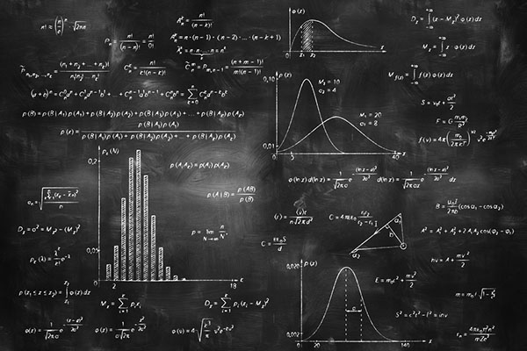

**Development Team:**

Jefferson Le

Tyler Pinho

Curtis Spence

**Table of Contents**

Table of Contents.........................................................................................................................1 Instructional Problem and Proposed Solution ..............................................................................2

Rationale for a Virtual World.........................................................................................................3

Target Audience and Setting.........................................................................................................3

Learning Objectives.......................................................................................................................4

Sample Assessment Items............................................................................................................4

Description of Treatment...............................................................................................................5

Content Outline.............................................................................................................................6

Program Flow................................................................................................................................7

Proposed Timeline........................................................................................................................8

Proposed Budget..........................................................................................................................8

References....................................................................................................................................9

**Statement of Instructional Problem and Proposed Solution**

When choosing what science classes to take, through middle school to college, students often decide to move away from, or avoid, Physics classes. Physics as a whole has built up a reputation  in our culture as being an extremely difficult and imposing principle. Despite this though Physics is a very fundamental building block in our understanding of the world and the sciences and as such it’s important that students have at least a basic understanding of Physics to ensure future success in STEM fields or at least the choice to pursue such things.

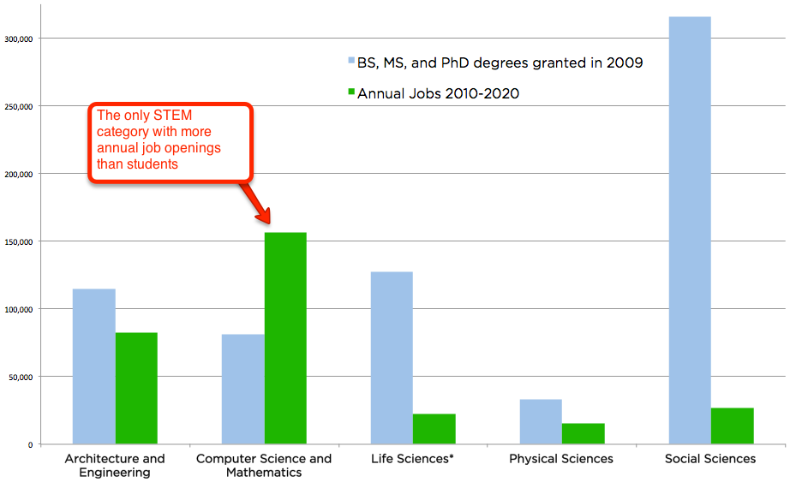

The graph above shows that not only are there fewer job openings annually for physics related positions, but that of all STEM fields Physics also has the lowest numbers of students as well. Since Physics is the foundation of so many fields, the lack of new blood and innovation in Physics will in turn create the same lack of innovation in other STEM fields as well. For example, lack of progress in physics will make it difficult to design new buildings to accommodate rising populations and food demands, advancements in physics need to be made in order for radical designs and materials to be realized for the future.

As such in order to help students develop these skills we propose to create a virtual world where students will practice their Physics basics in a way which will help dispel their fears surrounding the topic. To facilitate this the virtual world students will be participating in will be structured similarly to popular building destruction games like Angry Birds. During these games students will be presented with a variety of exercises that will build their skills in Physics such as finding the correct numbers to achieve a certain arc height when shooting a cannon. In this way the virtual world will already be familiar to students and help lower their reservations while also raising their engagement assisting them in learning much better than the more abstract lessons and exercises they are used to.

**Rationale for a Virtual World**

A computer-based program is the best solution for this instructional problem because students today are much more used to acquiring knowledge through technology then they are though traditional teaching methods. Physics as a subject fits particularly well for this because physics is utilized for most of the technological entertainment students consume. As such physics is already a part of the things students interact with daily and a virtual world is the best way to make this obvious to them and increase their engagement and learning. In addition by using a virtual world students can further enhance their understanding beyond what can be done in a classroom by being able to experience simulations of things they are unable to experience like the physics of space. Problems that use highly abstracted environments and variables are common in Physics (ie. environments without air resistance) and are often confusing for students and by using virtual worlds it becomes much easier to demonstrate these problems and the differences between them as a live visual representation that could not easily be shown now can be shown directly to the students.

**Target Audience and Instructional Setting**

The target audience for this is primarily middle school students, between the ages of 12-15, the primary reasoning behind this is that this is around the earliest time in which students are first introduced to the subject of Physics. We wish to target both male and female students equally well as well as target students of all ethnicities and backgrounds. However since this is a virtual world the target audience is going to be primarily thought of as middle class, with easy access to a computer and the internet in order to acquire the software. The instructional setting is primarily thought of as the student’s own self learning and environment and manner in which they choose to play the game which could either be in order to enhance their understanding of the subject or as a leisure activity for their enjoyment. It can also be employed in a classroom setting by teachers as a tool to help teach students as either another exercise to be used such as having the students play specific levels to illustrate difficult concepts, or for example as a consistent activity throughout the curriculum such as assigning some amount of levels per week as homework, creating a community around the game as students work together to overcome that week’s tasks.

**Learning Objectives**

The goal of this virtual world will be to provide a fun and immersive way for middle school students to learn of planetary physics and physics in space as well as how each of the physics equations is used in different scenarios. This game will rely on using Cognitive Apprenticeship via using a fun narrator to provide short learning lessons, objectives, and quirky fun dialogue in order to keep the lessons informative but not overbearing. Our virtual world will also use Constructivism by providing goal-based, fun levels that teach people lessons through actually performing the physics being taught.

Objectives

* Effects of Gravity
* Newton’s Three Laws of Motion
* Newton’s Law of Universal Gravitation
* Relation of Acceleration and Velocity
* Relation of Velocity and Position
* Effect of Mass on Force
* Learning How Each Physics Equation Applies to the World

**Sample Assessment Items**

1. Increasing the Force on an object will cause what else to increase?
   1. Mass
   2. Acceleration
   3. Friction
   4. Gravity
2. When a ball rolls on grass it has more friction than rolling on ice?
   1. True
   2. False
3. Newton’s 1st Law: An object in motion remains in motion unless ________
   1. Acted on by an outside force
   2. Friction is zero
   3. It collides with another object
   4. Acceleration is zero
4. 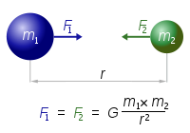What concept does the following figure represent?
   1. Newton’s 3rd Law
   2. Planetary Collision
   3. Newton’s Law of Universal Gravitation
   4. Orbits of Celestial Bodies

**Description of Treatment**

The virtual world will be a third-person puzzle-action game that takes a similar approach in game design to Angry Birds or Boomblox. The environments will be a hands-on experience where students will actively learn physics concepts through completing specialized stages that rely on utilizing a certain physics concept to destroy all of the blocks in the level in a limited number of attempts. This is done through the student learning about and manipulating the input of physics equations both on environments on Earth as well as in space.

There will be an in-game narrator that serves as the mentor for the player that provides them the learning objectives and advice on how to complete the level. The virtual world will have 3 sub-worlds built in with each having several stages. There are quizzes featured at the end of each world to test mastery and once all 3 quizzes are completed the player wins. Altogether this virtual world should take 20 minutes for a first time player to complete but may take up to 30 minutes depending on how well they can complete each level.

The entire project is virtual so no additional materials are going to be needed. All directions, testing, and teaching will be located in the game. The problems being tested are conceptual in nature so scratch paper and a calculator are unneeded but a strong willingness to learn new concepts will be needed.

Due to the whole experience being self-contained in the program, the instructor just needs to allow the students to play the game with no other additional procedures. The instructor can opt to make the experience more guided but that will not be covered in this virtual world as it is viewed to be optimal to have the students self-pace themselves in order to learn the best.

**Content Outline**

1. Title Screen
   1. Virtual World Title with Animated Screen
   2. Authors
   3. Credits
   4. Copyright
   5. Start Game
   6. Continue Game
   7. Options
2. Introduction
   1. Welcome
   2. Introduce Mentor Character
   3. Directions
   4. Learning Goals
   5. Tutorial Levels
3. World Map
   1. Three Worlds
      1. Earth Physics
      2. Physics in Space
      3. Advanced Earth Physics
   2. HUD
      1. Show Levels Complete Out of Total
      2. Display Physics Equations
      3. Current Level Name
   3. Levels
      1. Custom-Made to Highlight Specific Physics Concept
      2. Relevant to World Located In
      3. Mentor Provides Dialogue
4. Quiz Section
   1. Completed At End of Each World
   2. If Student Failed Quiz Link Back to Relevant Levels
   3. Completing All 3 Quizzes Leads to Completion
5. Completion
   1. Final Mentor Words
   2. Certificate of Completion
   3. Link Back to Title Screen

**Program Flow**

1. Title Screen

The game starts with the title showing overlaid on an animated backdrop of some in game scenery. The play start game button starts the game for the player, going into the introduction. Continue will bring the player to the level select screen with the amount of progress they have previously done showing. Options will bring up a volume control, a toggle for showing the tutorial/intro. Credits will show the names of the contributors to the project. Elsewhere on the screen will be copyright labels and the authors’ names.

1. Introduction

The intro will begin with a welcome screen via the virtual world Guide. After a brief introduction, the Guide will explain the basic game objective and mechanics to the player. On top of this, the learning objective of understanding various physics applications will be told to the player. From here, the player will enter a series of walkthrough levels that allow them the apply the mechanics they were told of as well as learn about the various game components they will encounter throughout the game.

1. World Map

From this screen, the player may navigate and select various regions based on different topics within the large spectrum of Newtonian physics, from planetary gravity to weightless physics and then finally the Advanced planetary physics. Within these regions will be various levels that pertain the world they reside in and will generally increase in complexity as they progress through their worlds. Selecting an unlocked/available level will send the player into the game where they will enter and manipulated various physics equations to achieve some goal for the level explained by the Guide. There will be a counter on the world map of how many levels have been completed compared to the total. Also, a back button to return to the main screen.

1. Post-World Assessment

After a world has been completed, an assessment of the player will be given in the form of a small quiz in order to determine the material they retained from the related world lessons. If failed, the player will be sent back to the levels related to the failed quiz material in order to let them relearn and hopefully hold onto the knowledge. Once all 3 quizzes are complete, the Completion screen will show.

1. Completion

The player wins! The Guide congratulates the player, a certificate is awarded, and the player is sent the start screen.

**Proposed Timeline**

|  |  |  |
| --- | --- | --- |
| **Section** | **Time (hours)** | **End Date** |
| Project Proposal | 5 | 9/27 |
| Proof of concept for different Physics interactions | 6 | 10/10 |
| Physics Equation to Gameplay Interaction | 8 | 10/17 |
| Project Design Doc | 6 | 10/19 |
| GUI Design | 15 | 11/7 |
| Scripting various physics elements | 20 | 11/9 |
| Level/World Design | 50+ | 11/14 |
| Texture/Modeling Design | N/A | 11/14 |
| Finish/Revise Week | 5-10 | 11/21 |

**Proposed Budget**

|  |  |  |
| --- | --- | --- |
| **Subject** | **Amount** | **Cost** |
| Custom Built Development PCs | 3 x $1300 | $3900 |
| Cintiq Artisan Pad | 1 x $2000 | $2000 |
| Unity Professional Licenses | $1500 | $1500 |
| Scripters Fee | 250 hours x $45 | $13,500 |
| Artists/Modelers Fee | 40 hours x $55 | $2200 |
| Food (Preferably Ike’s) | 2000 Sandwiches | $20,000 |
| **Totes** | **---** | **$41,300** |

**References**

<http://blog.code.org/post/89267280803/stem>

<http://elmspace.com/2014/12/30/why-do-students-hate-physics/>

<http://gravitee.tripod.com/axioms.htm>